**CODING CHALLENGE 1 (19-06-2025)**

**1. Update the daily rate for a Mercedes car to 68**

UPDATE Vehicle

SET dailyRate = 68

WHERE make = 'Mercedes';

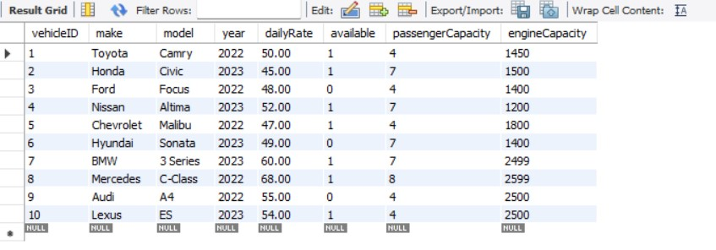

**2. Delete a specific customer and all associated leases and payments**

Replace 3 with the actual customerID you want to delete

DELETE FROM Payment

WHERE leaseID IN (SELECT leaseID FROM Lease WHERE customerID = 3);

DELETE FROM Lease

WHERE customerID = 3;

DELETE FROM Customer

WHERE customerID = 3;

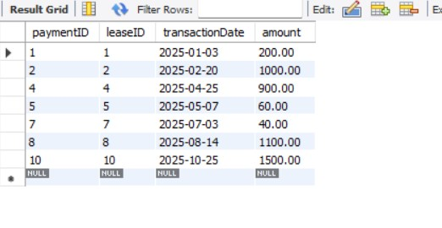

**3. Rename the "paymentDate" column to "transactionDate"**

ALTER TABLE Payment

RENAME COLUMN paymentDate TO transactionDate;

**4. Find a specific customer by email**

SELECT * FROM Customer

WHERE email = 'robert@example.com';

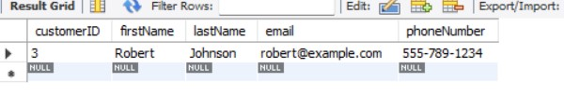

**5. Get active leases for a specific customer**

Replace 3 with the customerID

SELECT * FROM Lease

WHERE customerID = 3 AND CURRENT_DATE BETWEEN startDate AND endDate;

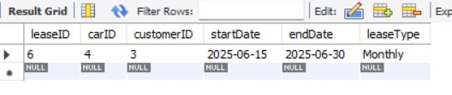

**6. Find all payments by a customer with a specific phone number**

Replace with actual phone number

SELECT P.* FROM Payment P

JOIN Lease L ON P.leaseID = L.leaseID

JOIN Customer C ON L.customerID = C.customerID

WHERE C.phoneNumber = '555-789-1234';

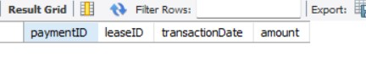

**7. Calculate average daily rate of all available cars**

SELECT AVG(dailyRate) AS averageDailyRate

FROM Vehicle

WHERE available = 1;

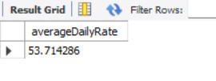

**8. Find the car with the highest daily rate**

SELECT * FROM Vehicle

ORDER BY dailyRate DESC

LIMIT 1;

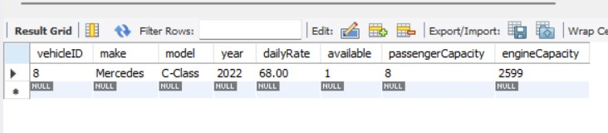

**9. Retrieve all cars leased by a specific customer**

Replace with actual customerID

SELECT V.* FROM Vehicle V

JOIN Lease L ON V.vehicleID = L.vehicleID

WHERE L.customerID = 3;

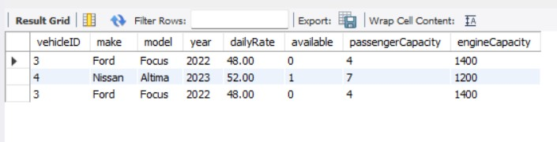

**10. Find the details of the most recent lease**

SELECT * FROM Lease

ORDER BY endDate DESC

LIMIT 1;

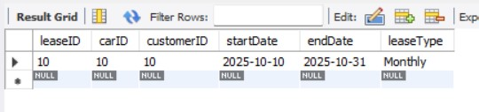

**11. List all payments made in the year 2023**

SELECT * FROM Payment

WHERE YEAR(transactionDate) = 2023;

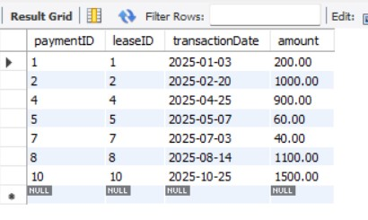

**12. Retrieve customers who have not made any payments**

SELECT * FROM Customer C

WHERE C.customerID NOT IN (

SELECT L.customerID

FROM Lease L

JOIN Payment P ON L.leaseID = P.leaseID

);

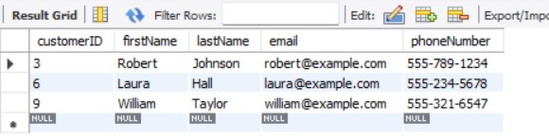

**13. Retrieve Car Details and Their Total Payments**

SELECT V.vehicleID, V.make, V.model, SUM(P.amount) AS totalPayments

FROM Vehicle V

JOIN Lease L ON V.vehicleID = L.vehicleID

JOIN Payment P ON L.leaseID = P.leaseID

GROUP BY V.vehicleID, V.make, V.model;

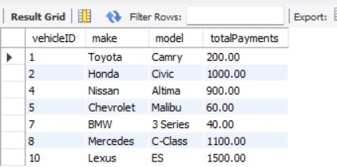

**14. Calculate Total Payments for Each Customer**

SELECT C.customerID, C.firstName, C.lastName, SUM(P.amount) AS totalPayments

FROM Customer C

JOIN Lease L ON C.customerID = L.customerID

JOIN Payment P ON L.leaseID = P.leaseID

GROUP BY C.customerID, C.firstName, C.lastName;

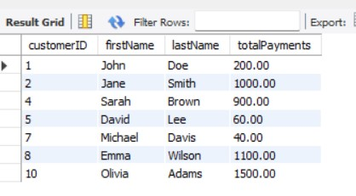

**15. List Car Details for Each Lease**

SELECT L.leaseID, V.make, V.model, V.year, L.startDate, L.endDate

FROM Lease L

JOIN Vehicle V ON L.vehicleID = V.vehicleID;

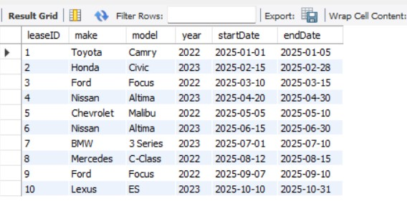

**16. Retrieve Details of Active Leases with Customer and Car Info**

SELECT L.*, C.firstName, C.lastName, V.make, V.model

FROM Lease L

JOIN Customer C ON L.customerID = C.customerID

JOIN Vehicle V ON L.vehicleID = V.vehicleID

WHERE CURRENT_DATE BETWEEN L.startDate AND L.endDate;

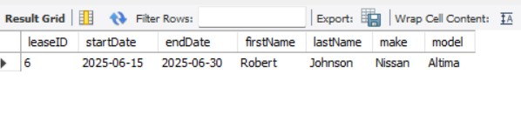

**17. Find the Customer Who Has Spent the Most on Leases**

SELECT C.customerID, C.firstName, C.lastName, SUM(P.amount) AS totalSpent

FROM Customer C

JOIN Lease L ON C.customerID = L.customerID

JOIN Payment P ON L.leaseID = P.leaseID

GROUP BY C.customerID, C.firstName, C.lastName

ORDER BY totalSpent DESC

LIMIT 1;

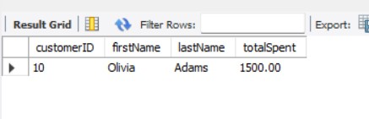

**18. List All Cars with Their Current Lease Information**

SELECT V.*, L.startDate, L.endDate, C.firstName, C.lastName

FROM Vehicle V

LEFT JOIN Lease L ON V.vehicleID = L.vehicleID AND CURRENT_DATE BETWEEN L.startDate AND L.endDate

LEFT JOIN Customer C ON L.customerID = C.customerID;

